**Exercise**

**Date: 04/04/2025**

**Experiment no: 03**

**Student No: EC/2021/006**

**02.**

**Source Code**

void knightrider(void) {

int i;

// Step 1: Set all pins of PORTB as outputs

TRISB = 0b00000000; // Set all PORTB pins as output

// Step 2: Initialize PORTB with the middle LEDs lit (RB3 and RB4)

PORTB = 0b00011000; // RB3 and RB4 ON (center LEDs)

// Step 3: Move LEDs from center to ends (both directions)

for (i = 0; i < 3; i++) {

PORTB = (PORTB << 1) | (PORTB >> 1); // Expand outward

Delay_ms(100); // Delay for smooth animation

}

// Step 4: Move LEDs back from ends to center

for (i = 0; i < 3; i++) {

PORTB = (PORTB >> 1) & (PORTB << 1); // Contract inward

Delay_ms(100); // Delay for smooth animation

}

}

void main() {

CMCON = 0b00000111; // Disable comparators (for older PICs)

TRISA = 0b00000000; // Set PORTA as digital output

while (1) { // Infinite loop

knightrider(); // Call the LED chaser function

}

}

**Porteous Simulation**

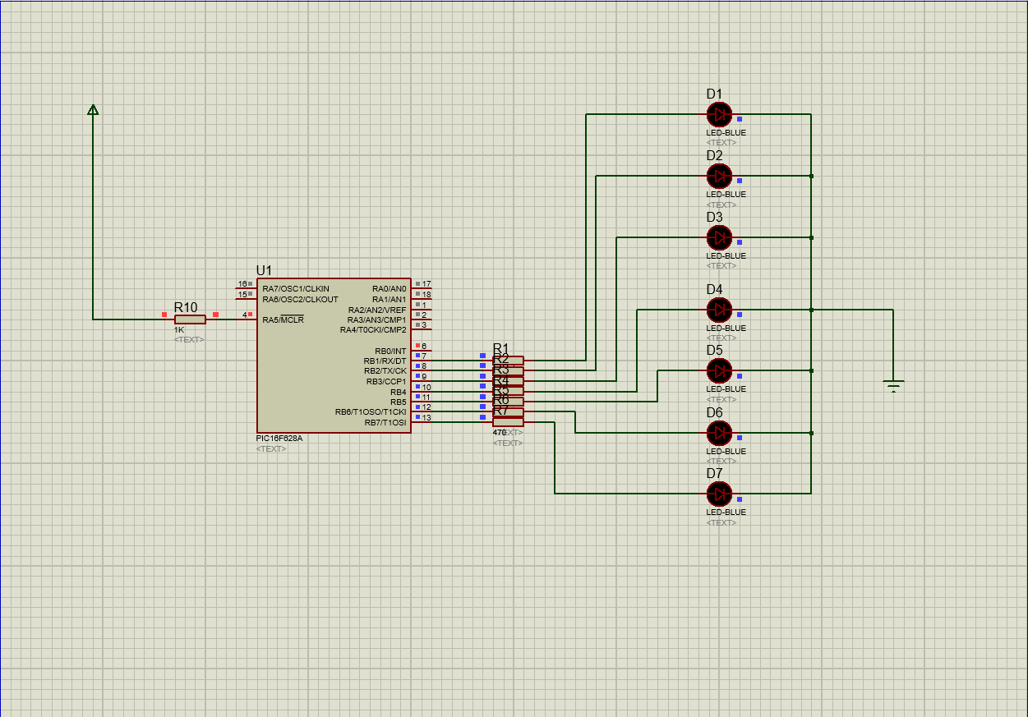

**03.**

**Source Code**

void knightrider(void) {

int i;

TRISB = 0b00000000;

PORTB = 0b00000001;

for (i = 0; i <= 3; i++) {

PORTB = (PORTB << 2);

Delay_ms(100);

}

for (i = 0; i <= 3; i++) {

PORTB = (PORTB >> 2);

Delay_ms(100);

}

}

void main() {

CMCON = 0b00000111;

TRISA = 0b00000000;

while (1) {

knightrider();

}

}

**Porteous Simulation**



